Project Design Phase
Solution Architecture

Date | 25 September 2026
Team ID | 6ab221c4bee0b08a2d2c6539
Project Name | Implement Client Script & UI Policy (Incident)
Maximum Marks | 4 Marks

Solution Architecture:
Solution architecture is a complex process – with many sub-processes – that bridges the gap between business problems and technology solutions. Its goals are to:
- Find the best tech solution to solve existing business problems.
- Describe the structure, characteristics, behavior, and other aspects of the software to project stakeholders.
- Define features, development phases, and solution requirements.
- Provide specifications according to which the solution is defined, managed, and delivered.

Architecture Diagram: Implement Client Script & UI Policy (Incident)
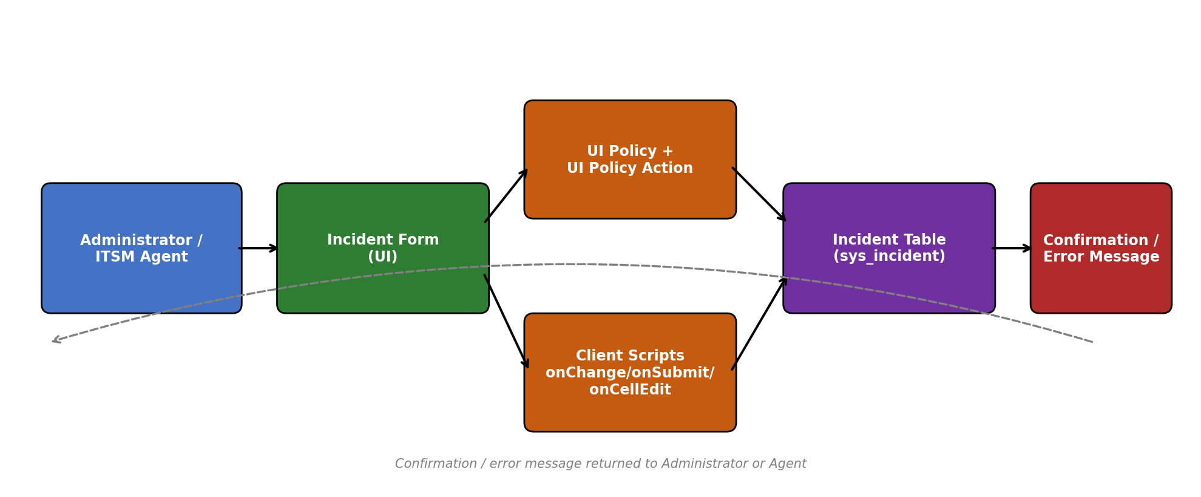
Figure 1: Architecture and data flow for UI Policy and Client Script enforcement on the Incident form

Component Description:
Component | Role in the Solution
Administrator / ITSM Agent | Opens the Incident form to configure or work with Incident records.
Incident Form (UI) | ServiceNow's native Incident form where field values are entered and edited.
UI Policy + UI Policy Action | The "High Impact Control" UI Policy (Impact = High) makes Assignment group mandatory and Urgency read-only, reverting when the condition is false.
Client Scripts | onChange auto-sets Urgency and messages the user; onSubmit blocks save when Assigned To is missing; onCellEdit blocks direct State edits from the list view.
Incident Table (sys_incident) | Stores the validated Incident record once all UI Policy and Client Script conditions are satisfied.
Confirmation / Error Message | Returned to the Administrator or Agent to confirm a successful save or to explain why the save/edit was blocked.

Reference: https://developer.ibm.com/patterns/visualize-unstructured-text/ ; ServiceNow Product Documentation - UI Policies & Client Scripts

